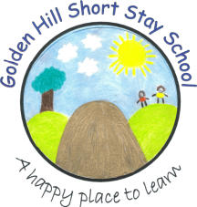

Sarah Barrett
Feb 2023

Curriculum Intent
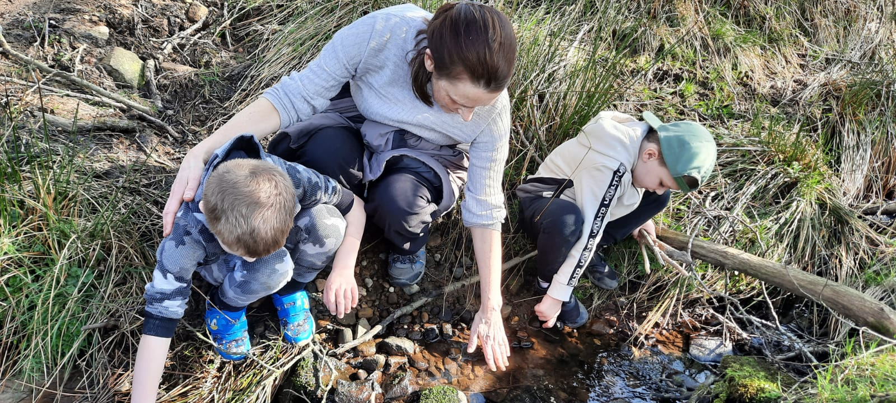
Recovery Curriculum

Due to the events of Covid-19, we acknowledge that there is a need for a change to the curriculum to support pupils during these exceptional circumstances. We understand that all pupils have had different experiences and therefore we aim to provide a flexible curriculum which will nurture and develop at the pace of the pupils.

Intent

‘Education is the most powerful weapon on which you can use to change the world’
Nelson Mandela

Our curriculum puts the child at the centre of our nurturing school, where positive relationships, based on mutual trust and respect are at the heart of everything we do. Our ambitious curriculum has been designed to take into account of the Early Years Foundation Stage curriculum, and the Primary National Curriculum, It exposes our children to enriching experiences, immersing them in knowledge and skills; equipping them with the personal characteristics required to succeed in life.

The key principles behind the design of our curriculum are for our children to

- be confident, independent and resilient, to understand that they are all successful learners.
- be kind, showing empathy and compassion whilst valuing diversity.
- understand the importance of truth and fairness, so that they grow up committed to equal opportunities for all.
- achieve academically across the curriculum, with particular focus on maths and English, to identify gaps in their knowledge and understanding, with the aim to meet their academic targets set .
- be culturally knowledgeable about our country and our world.
- value our environment, and to respect the world we live in and how we should care for it for future generations, as well as our own.
- be healthy individuals who enjoy sport and appreciate the importance of a healthy lifestyle.
- be well prepared and supported to access their new school provision whether that be mainstream primary, specialist provision or the challenges of the secondary school curriculum.
- have aspirations for the future and know that these can be reached through hard work and determination.

Ultimately, we want all our children, to be best they can be, making a positive contribution to the world they live in.

Implementation

PSHE and Values lie at the heart of the curriculum we deliver to closely meet the needs of our children. Our bespoke PSHE framework, focusing on well-being, positive self awareness, relationships and the wider world, was written after consultation with the school community. Our children have a wide range of opportunities which promote safety, including the pupil voice where all children are actively involved in whole school decision making through the School Council, Values Meeting and many positions of responsibility. Our curriculum recognises the importance of children’s’ physical and mental well being in shaping their long term life choices.

We believe that our fundamental task is to teach our children to speak clearly and articulately and to read and write effectively. Reading across all curriculum areas is a priority to extend and deepen pupils understanding and use of vocabulary, We want children to develop a love of reading during their time at Golden Hill and be exposed to a range of classic and contemporary literature. The use of the school library and class shared novels are pivotal to this.

In order to raise aspirations, develop an understanding and awareness of current local and national issues and equip children with a real belief that they can achieve anything if they are prepared to work hard, it is imperative that we prioritise experiential learning within our curriculum. Visitors are regularly invited into school, educational, adventurous activities and residential visits are carefully chosen to deepen understanding and we make the most of our Eagles outdoor learning environment to enhance hands on learning experiences.

Our primary curriculum is planned with a clear focus on the core aspects of English, Maths, Science and PSHE. We design a bespoke and flexible curriculum which is driven by the needs of our children. Termly, teachers plan and deliver a curriculum, including foundation subjects, to meet the specific needs of their current cohort. Subjects can be taught through weekly lessons, ‘blocked sessions’, projects, topic or cross curricular work and themed days / weeks. We believe our School Curriculum makes learning meaningful and relevant to our pupils, many of whom on entry to Golden Hill have become disengaged with learning.

For all subjects, we follow the National Curriculum, and then use the Lancashire Key Learning Documents to support our planning. For Foundation Subjects, each subject has a specific half term when it is taught. We use the PSHE Association Scheme of Work to plan and deliver a bespoke curriculum. PE is taught using the South Ribble Sports Partnership planning and the Lancashire Key Learning documents. We use the Lancashire Agreed Syllabus for RE. We use the NC Document 2014 for MFL and follow the Salut Scheme.

The Reception Curriculum meets the requirements set out in the Statutory Framework for EY Foundation Stage. Our curriculum planning focuses on the seven areas of learning:
Prime areas: personal, social and emotional development: communication and language: physical development Specific areas: literacy: maths: knowledge and understanding of the world; expressive arts and design. We fully support the principle that young children learn through play, and by engaging in well – planned structured activities. Teaching in the Foundation stage builds on the experiences of the children in their pre-school and mainstream school learning.

The Curriculum promotes the very best teaching and learning through the careful use of pupil observation, assessment and monitoring in order to set teacher learning targets for our children which are challenging and achievable. We want every learner to have the confidence to succeed. Our teachers structure learning through incremental steps in order to ensure learning tasks are both challenging and enjoyable. We seek to inspire our children to want to learn and give them the tools they need, including a sense of self-esteem and self- belief that they can learn. We want our children to become active in their own learning and to have a real sense of pride and achievement in their work

There is a focus on helping our children to develop resilience and courage to take risks with learning, without fearing failure. We seek to develop the skills of enquiry, creative thinking, reasoning, problem solving, information processing and evaluation across all aspects of the curriculum. We want our children to develop a high regard for themselves and others, learning to control and regulate their own feelings and behaviours as well as responding appropriately to the needs and feelings of others. Our goal ultimately is for our children to have the skill set, confidence and resilience to become fully immersed in self‐directed learning.

There are numerous opportunities for supporting the children’s Spiritual, moral, social and cultural development through all areas of the curriculum. Spiritual development is promoted through RE, PSHE and Values workshops. Moral development is promoted through class Circle Times, discussions about class and school rules, values, whole school meeting, nurturing time throughout the day. Social development is promoted through a wide range of collaborative learning experiences and opportunities for play, PSHE, School Council, British Values, Forest Schools, options, Values & Celebration Meeting. Cultural development is promoted through specific projects, visitors, RE topics, promoting values through positive sharing of the variety of languages and cultural identities of our children and their families.
We value parents and work in partnership with them to enrich the curriculum. Parents are informed about the curriculum through our SeeSaw app, class newsletters, school letters, homework and are positively encouraged to be involved. Parents can access the website to inform them about our curriculum.

We are continually reviewing and improving the curriculum we offer to our children. We want our School curriculum to evolve according to the needs of our children and to the issues of the community and the wider world.

Continuing Professional Development for all staff is a priority to ensure they have the necessary skills and knowledge to deliver the highest standards across the entire curriculum. Sports specialists work along side teaching staff to enhance curriculum delivery. Subject Leaders have the necessary expertise to play a pivotal role in both the design and delivery of their subject area: ensuring a clear progression of both skills and knowledge across the year groups, underpinned by a robust assessment system. They can confidently articulate how learning is developed for specific cohorts, to ensure a real depth of learning right across the school.

See Appendix 1 – Example of Key Stage 1 and Key Stage 2 timetable.
Appendix 2 – Example of curriculum coverage
Appendix 3 – Curriculum Planner

Impact:-

- Our children demonstrate confidence, independence and resilience, and have a real thirst for learning.
- Our children are able to form meaningful relationships based upon mutual respect and trust, recognising and celebrating differences, not only within the school community, but in the wider world as well.
- Our children have access to a wide and varied curriculum, allowing each of them to excel as individuals and be the best they can be.
- Our children are well prepared and supported to access their new school provision whether that be mainstream primary, specialist provision or the challenges of the secondary school curriculum.
- Our children have aspirations for the future and know that these can be realised with hard work and determination.
- Our children grow up being able to make a positive contribution to the world in which they live.

